Restricting and Sorting Data

1. a query to display the name (first_name, last_name) and salary for all employees whose salary is not in the range $10,000 through $15,000.

Ans:- SELECT FIRST_NAME, LAST_NAME, SALARY FROM employees WHERE SALARY NOT BETWEEN 10000 AND 15000;

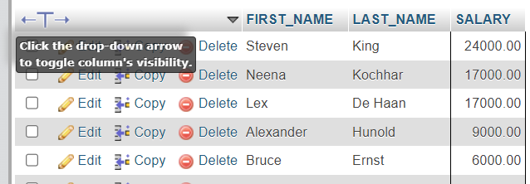

1. Write a query to display the name (first_name, last_name) and department ID of all employees in departments 30 or 100 in ascending order.

Ans:- SELECT FIRST_NAME, LAST_NAME, DEPARTMENT_ID FROM employees WHERE DEPARTMENT_ID BETWEEN 30 AND 100 ORDER BY DEPARTMENT_ID ASC;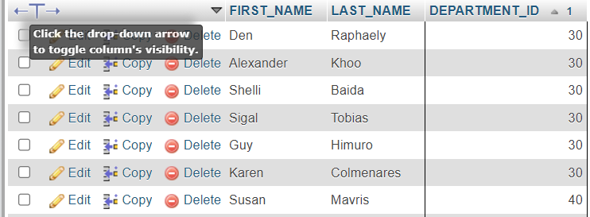

1. Write a query to display the name (first_name, last_name) and salary for all employees whose salary is not in the range $10,000 through $15,000 and are in department 30 or 100.

Ans:- SELECT FIRST_NAME, LAST_NAME, SALARY FROM employees WHERE SALARY BETWEEN 10000 AND 15000 AND EMPLOYEE_ID NOT BETWEEN 10 AND 30;

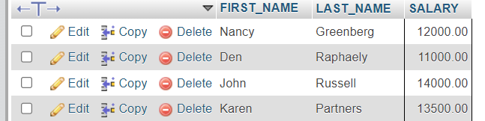

1. Write a query to display the name (first_name, last_name) and hire date for all employees who were hired in 1987.

Ans:- SELECT FIRST_NAME, LAST_NAME, HIRE_DATE FROM employees WHERE HIRE_DATE like '1987%';

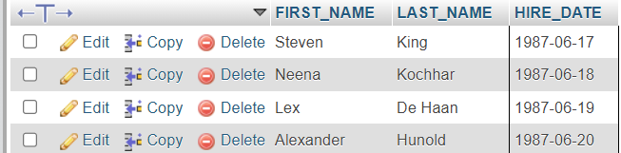

1. Write a query to display the first_name of all employees who have both "b" and "c" in their first name.

Ans:- SELECT FIRST_NAME FROM employees WHERE FIRST_NAME LIKE '%b%' AND FIRST_NAME LIKE '%c%';

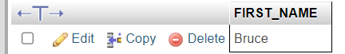

1. Write a query to display the last name, job, and salary for all employees whose job is that of a Programmer or a Shipping Clerk, and whose salary is not equal to $4,500, $10,000, or $15,000.

Ans:- SELECT LAST_NAME, JOB_ID, SALARY FROM employees WHERE JOB_ID IN ('IT_PROG', 'SH_CLERK') AND SALARY NOT IN (4500,10000,15000);

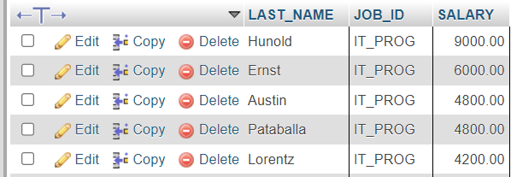

1. Write a query to display the last name of employees whose names have exactly 6 characters

Ans:- SELECT LAST_NAME FROM employees WHERE LAST_NAME LIKE '______';

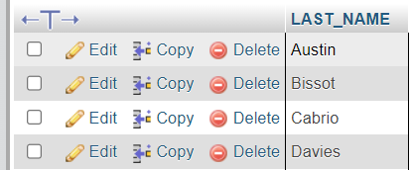

1. Write a query to display the last name of employees having 'e' as the third character.

Ans:- SELECT LAST_NAME FROM employees WHERE LAST_NAME LIKE '%e__';

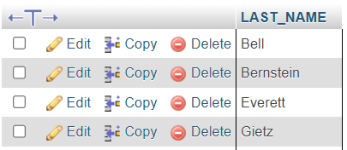

1. Write a query to display the jobs/designations available in the employees table.

Ans:- SELECT DISTINCT(JOB_ID) FROM employees;

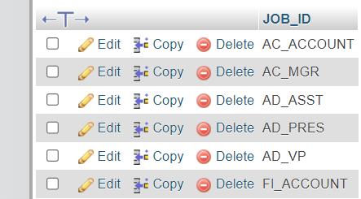

1. Write a query to display the name (first_name, last_name), salary and PF (15% of salary) of all employees.

Ans:- SELECT FIRST_NAME, LAST_NAME, SALARY, SALARY*0.15 AS PF FROM employees;

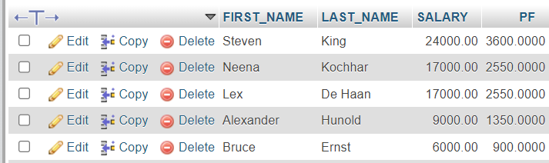

1. Write a query to select all record from employees where last name in 'BLAKE', 'SCOTT', 'KING' and 'FORD'

Ans:- SELECT LAST_NAME FROM employees WHERE LAST_NAME IN ('BLAKE', 'SCOTT', 'KING', 'FORD');

